1.Which shell are using – echo $0

2.Available shells -cat /etc/shells

3.To know which shell is user assigned-cat /etc/passwd

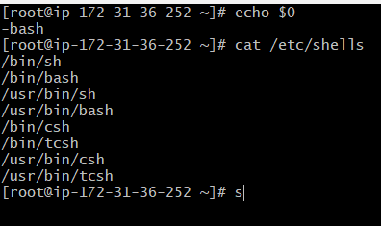

Task-1: sample Output to screen

#!/bin/bash

#Simple output script

echo "Hello World"

1.change the user to root user and give permissions by using chmod755.

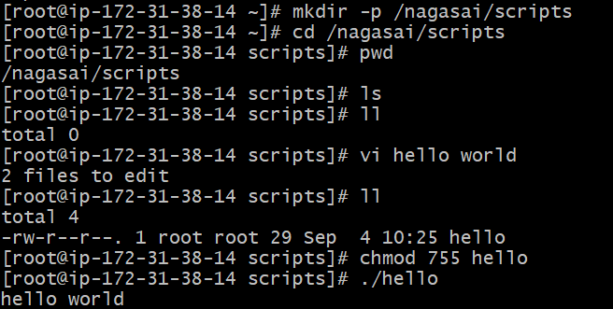

2.change the file from hello to .bash and write the data in the file by using VI.

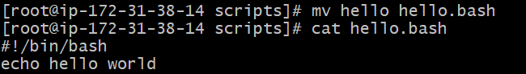

3.Read the file by using cat command and gives the output.

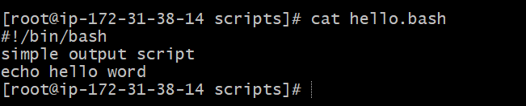

Task-2 Execute Basic commands

1.create a file with the extension of shell name

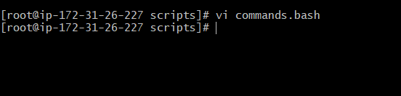

2.Enter the data to be executed and giving chmod755 permission.

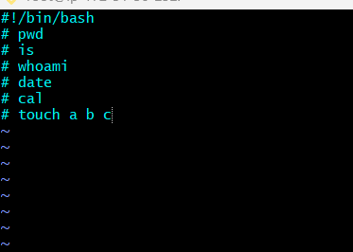

3.Execute the data by using ./filename.bash.

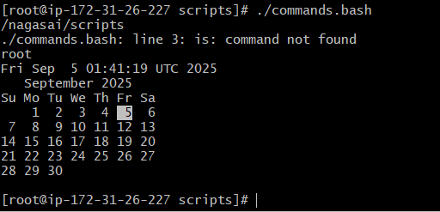

Task-3-Basic administration tasks

1.create a file with the extension of filename and giving permissions by using chmod.



2.Enter the data by using vi command.

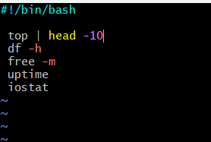

3.Execute it by using ./filename.sh

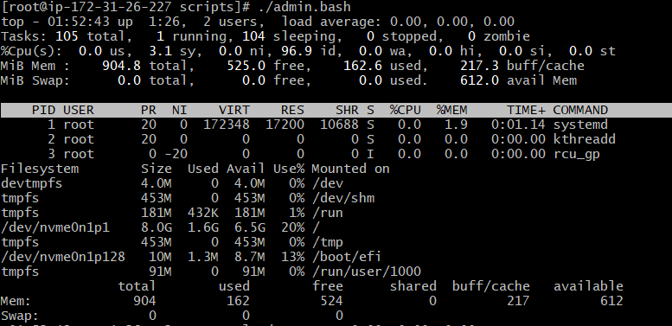Task-4-Execute basic variables

1.create a file with the extension of bash and giving permissions.. 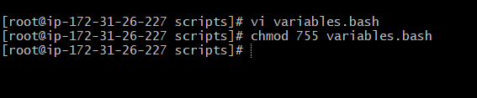

2.Enter the data by using vi command.

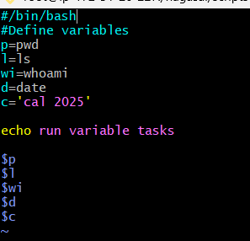

3.Execute it by using shell name.

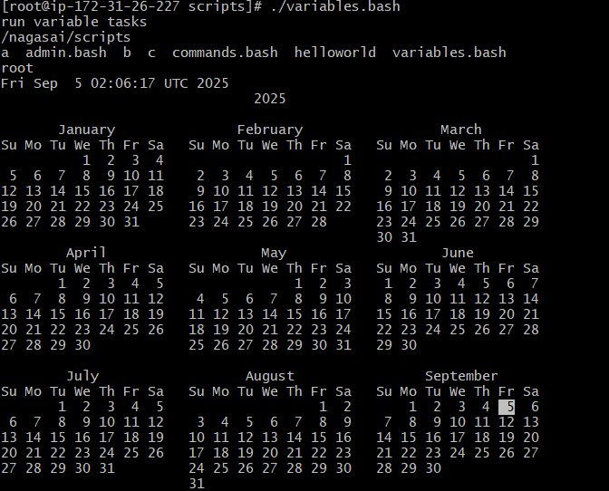

Task-5-scripts to execute a command in a variable



1.Enter the sample input data and giving permissions by using chmod



2.Enter the sample data to be executed.

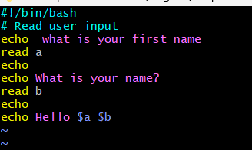

3.Execute it by using ./filename.bash.



